Pension Auto-Enrolment
The Government wishes to increase pension scheme membership to help people save for their retirement. In order to deliver this policy the Government introduced new legislation, the Pensions Act 2008, which contains new employer requirements commonly referred to as “auto-enrolment”.
Under the legislation, employers must automatically enrol all eligible jobholders, working for them, into a workplace pension scheme that meets certain requirements, and to provide a minimum employer contribution.

How will this affect you?
If you ARE already a member of one of the University’s pensions schemes you will not be affected by auto-enrolment as long as you remain in the pension scheme. However, you will receive a letter informing you that you are a member of a qualifying pension scheme.
If you ARE NOT currently a member of one of the University’s pensions schemes you will be sent a letter that explains which of the 3 groups, Eligible jobholders; Non-Eligible Jobholders or Entitled Workers you have been allocated to and informs you about the opt-out process.
Pension scheme membership is not compulsory. Following auto-enrolment, eligible jobholders who do not wish to remain in the pension scheme have a ONE MONTH period in which to use an opt-out mechanism. This will ensure that no pension deductions are made from their pay.

From September 2013
The University will:
- Ensure that it provides a qualifying pension scheme available for all employees and other workers.
- Assess the entire workforce, not currently enrolled in a qualifying pension scheme, and allocate each individual to one of 3 groups: Eligible jobholders, Non-Eligible Jobholders and Entitled Workers and communicate this assessment to them describing their rights and the University’s responsibilities.
- Automatically enrol all eligible jobholders into the appropriate qualifying scheme.
- Ensure that the pension schemes establish processes that permit eligible jobholders who do not wish to remain in the pension scheme the option to opt out in the statutory one-month opt out period.
- Establish processes that will re-enrol opted-out eligible jobholders back into the scheme on a three-year cycle
- Continually monitor the workforce to ensure that, where individuals move between groups, the auto-enrolment legislation is followed.
- Ensure that, from 1st September 2013, all new workers are assessed for automatic enrolment onto the appropriate pension scheme.

Qualifying pension schemes
Under the legislation all employers must establish “Qualifying Pension Schemes” which meet or exceed certain minimum standards. Both of the University’s existing pension schemes, open to new entrants, exceed these standards and will therefore be used for auto-enrolment.
For auto-enrolment purposes “workers” are divided into 3 sub-groups, Eligible jobholders; Non-Eligible Jobholders and Entitled Workers.
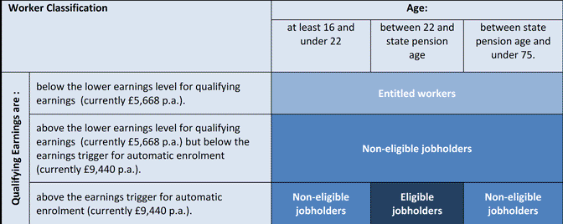
Where:
Eligible jobholders | Are “eligible” for automatic enrolment – both jobholder and the University must make contributions into the scheme
Non-eligible jobholders | Are "not eligible" for automatic enrolment but can choose to opt in to a pension scheme - both jobholder and the University must make contributions into the scheme
Entitled workers | Are “entitled” to join a pension scheme –Employers are not compelled to make contributions, although the University has decided that it will make contributions at the same level as for other jobholders.

Where can I find more information about auto-enrolment?

General information about Auto-enrolment
You can find out more general information about auto-enrolment by visiting the Pensions Advisory Service website here:
- Pensions Advisory Service - Automatic Enrolment

