Frequently Asked Questions for the Reach Bursary during the 2021/22 academic year

Who is Eligible for a Reach account?

All University of Worcester students are eligible to have a Reach account and have access to the John Smiths shop. The shop can be used in the same way as any other online retailer.

Who is Eligible for the Reach Bursary in the 2021/22 academic year?

First year undergraduate & PGCE students who are full-time, paying maximum annual tuition fees to the University of Worcester and joining us in 2021 are eligible to receive £100 to spend on their Reach account in the 2021/22 academic year.

Full-time Undergraduate students who are continuing their studies in September 2021, or starting in the second year of a course or taking a top-up in 2021 and are paying maximum annual tuition fees to the University of Worcester will receive £50 Reach credit to spend in the online reach store.

I am an international student, am I eligible for a reach award in the 2021/22 academic year?

New for the 2021/22 academic year, full time undergraduate & PGCE International students paying maximum fees to the University of Worcester in 2021/22 are now eligible for an award if they satisfy the eligibility criteria specified above.
(N.B. International students enrolled with the University of Worcester International College (UWIC) are NOT eligible for a reach award. Course fees for students enrolled with UWIC are paid to UWIC, not the University of Worcester.)

Do I need to create a Reach account myself in order to receive the bursary?
If you are eligible for an award and a first year student or have not previously had a Reach account, the account will be created automatically for you. Once your account has been created you will receive an email from the Reach team at John Smiths giving you details on how to access the account and your Reach credit. If you already have a reach account from previous years, your credit will be added to this account.
How will I receive the Bursary?

The bursary will take the form of credit added to a student Reach account. If you are eligible for an award, you will receive an email from the Reach team at John Smiths, which will provide details on how to spend the bursary.

Can I have the bursary as cash rather than credit on my Reach account?

The Reach bursary is only available as credit in the UW online Reach store and cannot be given as cash.

I have not received an email about the Reach bursary, what should I do?

If you are eligible for a bursary the email would have been sent to your university email address, not your personal email address. Please ensure you have checked the correct email account and check your spam, junk and deleted items folders.
If you believe you meet the eligibility criteria detailed above but have not received an email please contact reach@worc.ac.uk.

I am not eligible for the Reach bursary; can I still use the online shop?
All University of Worcester Students can use the online shop in the same way as any other online retailer. Visit http://www.worcester-Reach.co.uk/ to register. You will need to use your university email address.

How do I spend my funds?
If you are eligible for a Reach bursary, you will receive an email via your University email account. This will tell you how to access your Reach account and redeem the bursary. Once you have done this you will be able to login to your account at www.worcester-Reach.co.uk and start buying your course books and equipment.

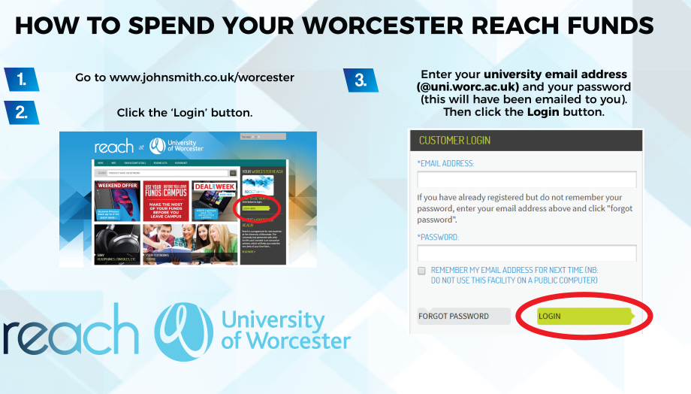

What can I spend my funds on?

You can spend your funds online at www.worcester-Reach.co.uk on any product that is available on our website, including textbooks, stationery, electronics and other learning materials.
Is this a loan? Do I have to pay it back?
Your Reach award is not a loan and you do not have to pay it back. The funds are provided for you by the University to help you with your studies for as long as you are a student at the university.
When you leave the university your Reach account will be closed and any outstanding balance will expire.

What happens when I leave the university?

When you leave the university (e.g. because you have completed your course or because you have withdrawn from your course), when you cease to be a registered student your Reach account will be closed and any outstanding balance will expire.
If I purchase an eBook how do I access it?
If you purchase an eBook from the Reach store, this will either be with Kortext or adobe. Either way you will receive an email with instructions on how to access the book. There will be no additional charges for an account. More information can be found on the reach website - https://www.johnsmith.co.uk/ebooks-policy

What do I do if I have a query with my online order?
Please contact orders.js@johnsmith.co.uk with your query.

Will my personal data be shared with any third party?
Your data will only be shared with The University of Worcester, John Smiths and Kortext. See the data protection statement for full details.

What do I do if I have forgotten my Reach login details?
In order to login to the site and use your funds, you must always use your University e-mail address. If you have forgotten your password, click the Forgot Password button when trying to log in to your account (please see guide below). You will then receive an email giving you instructions on how to re-set your password. Please check you spam/ junk folder if the email does not appear in your inbox.

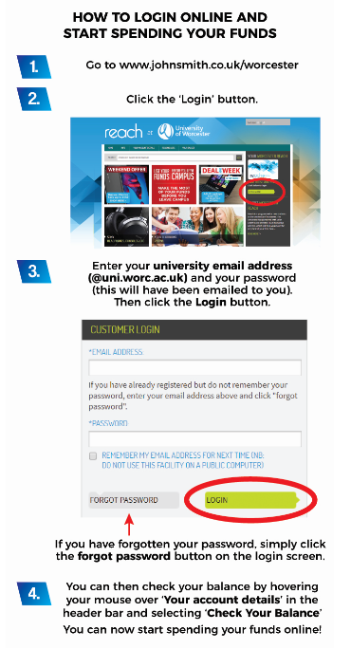

Q. I have a query about my Reach account that is not answered here, who do I contact?

If you have a query about your Reach account, please contact worcester@johnsmith.co.uk.
If you have any other queries about Reach, please contact Reach@worc.ac.uk

