Practice Assessment Document

Guide to using the PAD

Return to Practice Programmes
Part 3: Standards for return to practice programmes (NMC 2019) and Future Nurse: Standards of proficiency for registered nurses, (NMC 2018)

This Practice Assessment Document has been developed by the West Midlands Return to Practice Group in collaboration with practice learning partners, academic staff, returners and service users across England.

The development of this document builds on the work undertaken by the PAN London Practice Learning Group funded by Health Education England.

Introduction

The purpose of this guide is to provide guidance for the completion of the Pan England Practice Assessment Document (RTP PAD). General guidelines are provided for each element within the PAD. This guidance should be read alongside specific instructions that may apply to individual Universities.

The RTP PAD has been developed to ensure that returner nurses are prepared to successfully meet the Future Nurse: Standards of proficiency for registered nurses (NMC 2018) and Part 3: Standards for return to practice programmes (NMC 2019). The NMC standards specify the knowledge and skills that Registered Nurses must demonstrate when caring for people of all ages and across all care settings and comprise seven platforms and two annexes. The role of the Nurse in the 21st century is to provide care for people who have complex mental, physical, cognitive and behavioural care needs across a range of settings including people’s own homes, in the community or hospital or any health care setting.

The platforms are:
- Being an accountable professional
- Promoting health and preventing ill health
- Assessing needs and planning care
- Providing and evaluating care
- Leading and managing nursing care and working in teams
- Improving safety and quality of care
- Coordinating care
Annexe A: Communication and relationship management skills Annexe B: Nursing procedures

The outcome statements within the standards of proficiency apply across all fields of nursing practice (Adult, Children, Learning Disabilities and Mental Health) and all care settings as Registered Nurses must be able to meet the person-centred, holistic needs of the people they encounter in their practice who may be at any stage of their life and who may have a range of mental, physical, cognitive or behavioural health challenges.

The annexes within the standards of proficiency also apply across all fields and demonstrate what Registered Nurses should be able to demonstrate at the point of Registration. The level of expertise and knowledge required for both annexes will vary dependent on the chosen field(s) of practice. Registered Nurses must be able to demonstrate the ability to undertake these skills and procedures at an appropriate level for their intended field(s) of practice.

Practice Supervisors, Practice Assessors and Academic Assessors have an important role in supporting and guiding the returner through their learning experience. This includes facilitating any reasonable adjustments the returner may require to achieve the maximum benefit from the placement. Descriptions of these roles can be found within this guide.

As well as undertaking the required assessments, the role of the Practice Supervisor and Practice Assessor also includes identifying relevant learning opportunities and creating learning and development plans with the returner.

The document has been designed around the following Components of Assessment and Feedback:

  - Self-assessment against Future Nurse: Standards of Proficiency for Registered Nurses (NMC 2018)
  - Initial, Mid-Point and Final Interviews
  - Professional Values
  - Assessment of performance
  - Episodes of Care x 2
  - Medicines Management
  - Patient/Service User/Carer Feedback Form
  - Record of communication/additional feedback

[N.B. The screen shots currently include the Mapping Codes from the Future Nurse: Standards of proficiency for registered nurses (NMC 2018).

Criteria for Assessment in Practice

To be achieved by the end of the programme
Practising independently with minimal supervision and leading and coordinating care with confidence
All returners are supernumerary (NMC 2019 p9).The decision on the level of supervision provided should be based on the needs of the individual returner. The level of supervision can decrease with increasing proficiency and confidence. (NMC, 2018, p 5)

Leads and coordinates care

‘Achieved’ must be obtained in all three criteria by the returner

Achieved | Knowledge | Skills | Attitude and Values
YES | Has a comprehensive knowledge base to support safe and effective practice and can critically justify decisions and actions using an appropriate evidence base. | Is able to safely, confidently and competently manage person centred care in both predictable and less well recognised situations, demonstrating appropriate evidence-based skills. | Acts as an accountable practitioner in responding proactively and flexibly to a range of situations. Takes responsibility for own learning and the learning of others.
NO | Is only able to identify the essential knowledge base with poor understanding of rationale for care. Is unable to justify decisions made leading to unsafe practice. | With minimal supervision is not able to demonstrate safe practice despite guidance. | Demonstrates lack of self-awareness and professionalism. Does not take responsibility for their own learning and the learning of others.

Returners Responsibilities
You should take responsibility for your own learning and know how to access support and;  - Engage positively with all learning opportunities  - Understand the assessment requirements  - Work with and receive written feedback from a range of staff (including identified Practice Supervisors) and Service-Users  - Reflect on your own learning  - Provide feedback on learning experience  FAQs  Q: When should I contact my allocated placement?  A: It is advisable to contact your allocated placement in advance of starting your placement to obtain the information you need to enable you to prepare.  Q: Who will supervise me on placement?  A: You will be supported by a number of Practice Supervisors who will support your learning and can contribute to assessment.  Q: Who will assess me on placement?  A: You will have a nominated Practice Assessor for your placement, who is responsible for assessing and confirming proficiency and achievement. The Practice Assessor will liaise with the Practice Supervisor and Academic Assessor to obtain feedback on your progress.  Q: Will there be support from the University when on placement? A: You will have a named Academic Assessor. The Academic Assessor will liaise with your Practice Assessor. If you have any concerns on placement you should raise these with the university as soon as possible. | 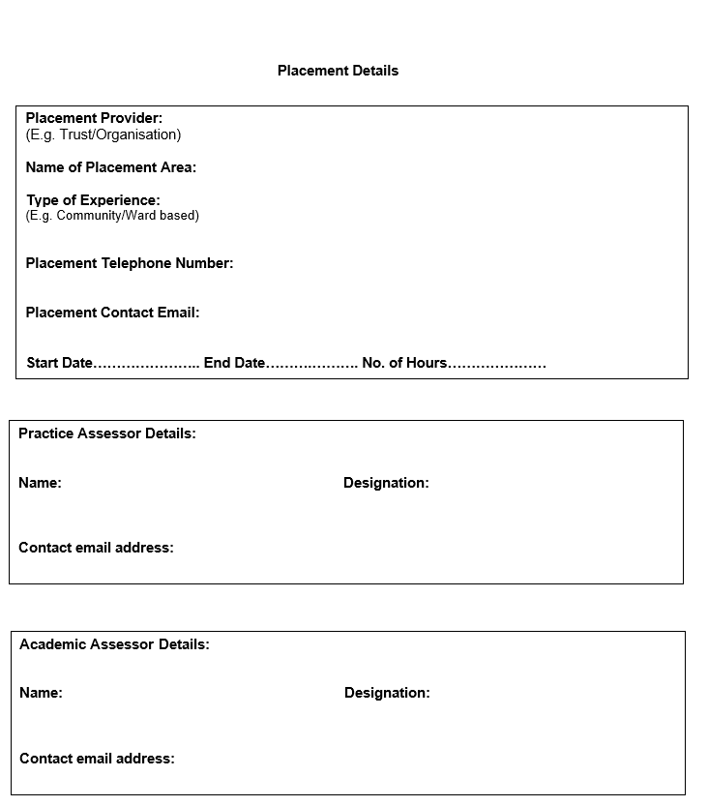

Practice Supervisor Responsibilities
Practice Supervisors (PS) are Registered Nurses or Midwives or Registered health or social care professionals. They have current knowledge and experience and are appropriately prepared for the role;  - Ensures learning opportunities are facilitated  - Contributes to assessment and records regular feedback  - Seeks feedback from other supervisors  FAQs  Q: What is my role in supporting the returner?  A: You have responsibilities for overseeing the returner’s progress during the placement. You will undertake the initial interview in the placement with the returner which includes supporting the returner to identify their learning opportunities and completion of the learning plan.  Q: What is my role in assessing the returner?  A: The Practice Assessor has responsibility for returner assessment. Practice Supervisors have an important role in contributing to assessment and giving regular feedback and the following can be undertaken by the Practice Supervisor to contribute to the returner’s assessment;  - Initial interview on placement  - Professional Values at midpoint interview  - Episodes of care; relevant to your scope of practice and professional role  Q: What is my relationship with other identified roles?  A: You will record feedback on the returner’s progress and liaise with other Practice Supervisors and the Practice Assessor to give feedback to inform the Practice Assessor’s decisions.  Q: What if I am not a registered nurse and supervising the returner? : A range of Registered health or social care professionals can support and supervise returner learning and contribute to the assessment within their scope of practice. | 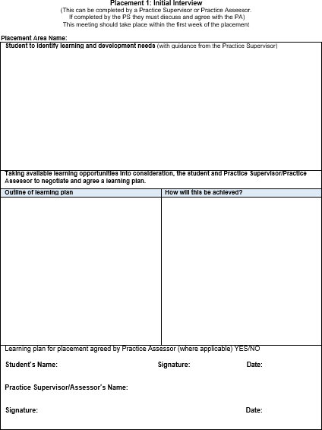

Practice Assessor Responsibilities
Practice Assessors (PA) are Registered Nurses or Midwives with current knowledge and expertise and are appropriately prepared for the role;  - Conducts assessments, informed by feedback from Practice Supervisors  - Makes and records objective decisions, drawing on records, observations, returner reflection and other resources  - Periodically observes the returner  - Gathers and coordinates feedback from Practice Supervisors and other relevant people  - Schedules communication with Academic Assessors at relevant points  FAQs  Q: What is my role in assessing the returner?  A: You have responsibility for returner assessment and will liaise with the Practice Supervisors to obtain feedback and Academic Assessors to discuss returner achievement and progression. You will review assessment documentation in the PAD that has been completed by a range of other health or social care professionals who have contributed to aspects of assessment.  Q: What specific elements do I need to assess and document? A: The Practice Assessor assesses;  - Initial interview (can be undertaken by Practice Assessor or Practice Supervisor; if PS undertakes, must be agreed by PA)  - Midpoint interview  - Assessment of performance  - Professional Values at final interview  - Final interview  - Confirmation of episodes of care  - Medicines Management  Q: What is my responsibility when a returner’s performance causes concern?  A: If a returner requires an Action Plan, you should liaise with the  Academic Assessor. Depending on the AEI and the local practice placement policy you may have to inform the nominated person. | 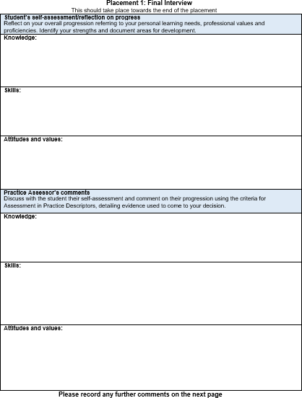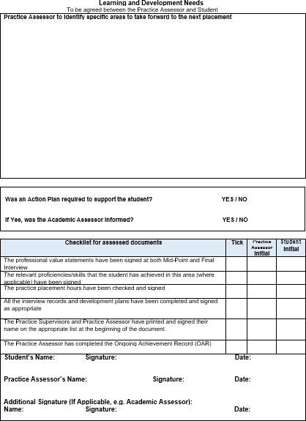

Academic Assessor Responsibilities
Academic Assessors are Registered Nurses or Midwives and are nominated and are appropriately prepared for the role;  - Ensures that the returner has completed all mandatory activities prior to placement  - Has understanding of the returner’s learning and achievement in practice  - Enables scheduled communication and collaboration between Academic and Practice Assessors  FAQs  Q: What is my role in relation to returner assessment?  A: The returner has an Academic Assessor who provides an overview of returner achievement to inform progression. If there is cause for concern in relation to the returner’s performance you should be involved in agreeing an Action Plan.  Q: Who will I liaise with?  A: You will communicate and collaborate with the Practice Assessor at relevant scheduled points during the Placement. This may be in person, via email or telephone as appropriate.  Q: What is my responsibility in relation to the returner’s progression towards registration?  A: The Academic Assessor will review and confirm the overall achievement in the PAD and recommend progression to registration. | 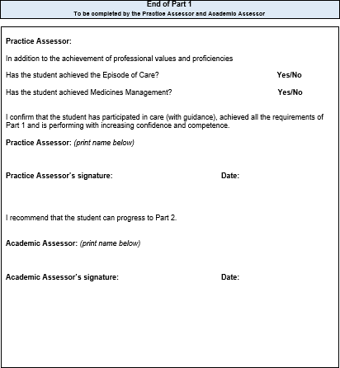

Document Signatories and Checklist for assessed documents
There are separate pages for Practice Supervisors, Practice Assessors and Academic Assessors to record information. It is your responsibility to complete these details.  Any Registered professional who writes in the PAD must complete the appropriate signatory’s page. This includes the record of orientation, record of communication and/or record of practice hours.  This is required by the University to cross reference and prevent falsification of records.  Please ensure that you insert your name, signature and date as required throughout the document.  Checklist for assessed documents:  At the end of each placement in the final interview, the Practice Assessor completes the checklist to confirm all components have been assessed and records signed. | 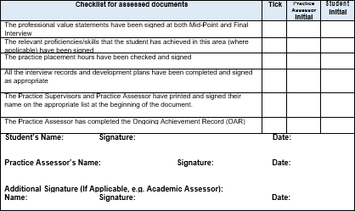

Orientation
There are some elements of orientation that must be completed on the first day on each placement. Refer to orientation page in the Practice Assessment Document.  FAQs  Q: Who can orientate the returner and complete this page?  A: An appropriate member of staff familiar with the area, as identified by the nominated person/local manager can complete the returner orientation and sign the appropriate section of the PAD.  Complete the appropriate signatory page. | 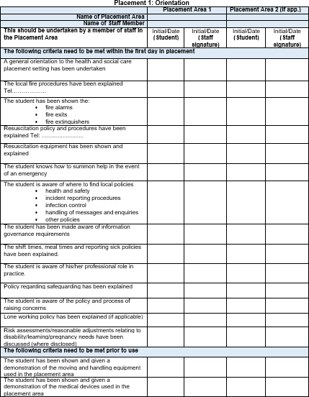

Initial, Mid-point and Final Interview
The interviews provide a formal record of returner learning, reflections and achievement. Returners are encouraged to take responsibility for their own learning and record reflections.  Initial interview:  This is completed by the returner with support from the Practice Supervisor or Practice Assessor who will identify the learning opportunities available during the placement and will reflect on their achievements. If the Practice Supervisor completes the initial interview with the returner this needs to be confirmed by the Practice Assessor.  Mid-point interview:  This is completed by the returner and the Practice Assessor who will review progress and if there are causes for concern the Practice Assessor will liaise with the Academic Assessor and complete an action plan.  Final interview:  This is completed by the returner and the Practice Assessor who will review progress and confirm achievement. At the end of the interview the Practice Assessor must complete the checklist for assessed documents. | 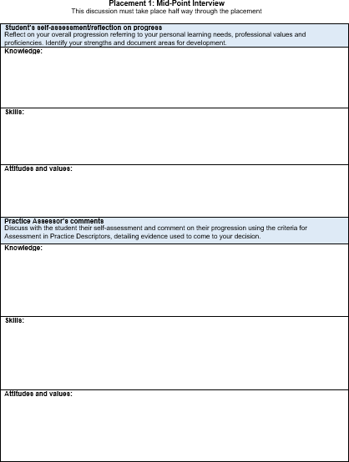

Professional Values
Returners are required to demonstrate high standards of professional conduct at all times during their placements. Returners should work within ethical and legal frameworks, and be able to articulate the underpinning values of The Code (NMC, 2019). The Professional Values reflect a number of proficiency statements and are captured within The Code.  Returner reflection on meeting Professional Values:  The returner selects examples from practice (this can be linked with the episodes of care) to demonstrate how they practise within The Code. Confidentiality in relation to people receiving care and service providers should be maintained.  Returner achievement:  The returner needs to demonstrate continued competence and confidence in the proficiency.  FAQs  Q: Who assesses the professional values?  A: The Practice Supervisor or Practice Assessor can assess the mid- point professional values. If the Practice Supervisor assesses the mid- point this will be reviewed and agreed by the Practice Assessor. The final Professional Values on each placement are assessed by the Practice Assessor who will discuss and review with the returner their reflection. If there are any concerns raised these should be discussed with the Academic Assessor. | 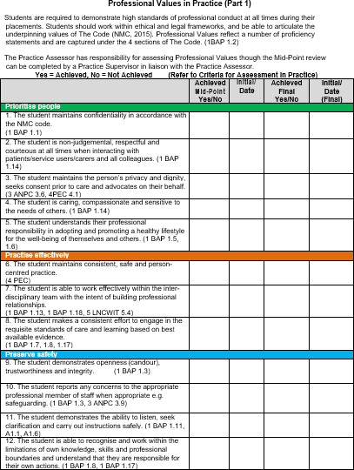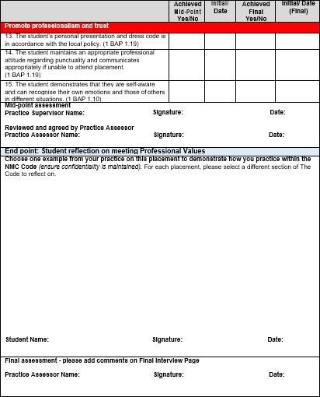

Patient/Service User/Carer Feedback Form
Within each placement there is a page for the returner to receive feedback directly from someone they have cared for and/or carers. Practice Supervisors or Practice Assessors are asked to support returners by facilitating this and asking people or their families to complete the form and they should sign this on completion.  FAQs:  Q: Who asks the person receiving care or carer to complete the form?  A: The Practice Supervisor/Practice Assessor should obtain consent from patients/service users/carers who should feel able to decline to participate.  Q: Does the person receiving care or carer have to sign the form?  A: No. The Practice Supervisor/ Assessor must sign this.  Q: How is the feedback used in the assessment process by the Practice Supervisor and Practice Assessor?  A: The returner will reflect on the feedback provided by the patient/service user/carer and discuss the outcomes, including any changes to practice that need to be made which can be included in the interviews or in an Action plan. | 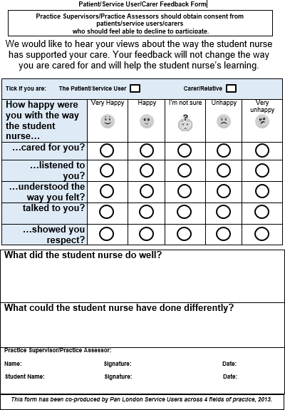

Record of Communication and Additional Feedback
These records can be completed by Practice Supervisors, Practice Assessors, Academic Assessors or any other members of the team involved in the supervision and assessment of the returner.  Complete the relevant signatory page.  This is for additional feedback that has not previously been documented in the PAD.  FAQs  Q: Should other members of the team be Registered professionals? A: No. It may be appropriate for an experienced health care assistant to give feedback on working with the returner. However they would not be contributing to assessment decisions.  Q: What type of information should be recorded?  A: Any relevant information that can be used in the assessment process, or that records the returner’s progression. | 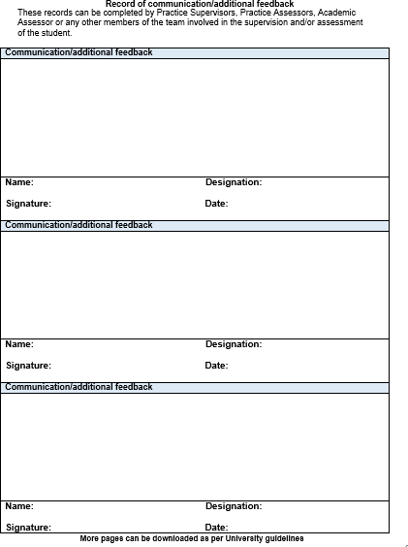

Assessment of Proficiencies
Assessment of the Proficiencies is undertaken across the whole placement. Achievement of proficiencies allows returners be able to deliver safe and effective care in their intended area of practice to a diverse range of people (NMC 2019 p9).  The proficiencies ‘apply to all registered nurses, but the level of expertise and knowledge required will vary depending on the chosen field(s) of practice’. (NMC, 2018, p22, 26).  The proficiencies are reviewed prior to the start of the placement in a meeting between the Practice Assessor, Academic Assessor and returner, where the returner with support reviews their current knowledge, skills and attributes. This facilitates the identification of the proficiencies which will be the focus of the placement.  The proficiencies are further reviewed for progress at the mid-point and then at the final interview. Where opportunity has not been afforded to complete specific proficiencies, they can be demonstrated using simulation or via an evidence based discussion. | The returner completes a tripartite review of their current knowledge and experience in partnerships with the Practice Assessor and Academic Assessor. Where a returner demonstrates the required level of knowledge, skills, attitudes and values, the proficiency/skill can be signed off.  For the remaining proficiencies, the Practice Supervisor and Practice Assessor should draw on a range of observed experiences in which the returner demonstrates the required knowledge, skills, attitudes and values to co-ordinate high quality person/family-centred care, ensuring all care is underpinned by effective communication skills. Exceptionally a proficiency can be demonstrated using simulation or via an evidence based discussion.  Q: What is the aim of the Tripartite review of Proficiencies?  A: The tripartite review of proficiencies will help the returner identify areas of development. The Assessment of Proficiencies is undertaken across the placement.  Q: Whose responsibility will it be to complete the tripartite review?  A: The Proficiencies are reviewed prior to the start of the placement in a meeting between the Practice Assessor, Academic Assessor and returner, where the returner with support reviews their current knowledge, skills and attributes. This facilitates the identification of the proficiencies which will be the focus of the placement.  Q: What is the role of the academic assessor?  A: The academic assessor should:  - Check the tripartite review has been completed prior to placement  - Liaise with the Practice Assessor during the placement

Episode of Care
Episodes of Care are holistic assessments which enable the returner to demonstrate progression across a number of platforms and must be achieved by the end of the placement. Effective communication and relationship management skills underpin all aspects of care. This assessment must be completed by a Practice Assessor.  Formative - episode of direct care meeting the needs of a person receiving care.  Summative - episode of direct care meeting the needs of a person receiving care.  Episode of Care 1 – teaching: The Returner will be given the opportunity to supervise and teach a junior learner/colleague/service user/carers in practice and provide a written reflection on this experience. This needs to be based on the delivery of direct person-centred care.  Episode of care 2 – leading and management of care: The practice assessor and returner will identify an appropriate episode of direct care involving the organisation and management of care for a group/caseload of people.  Returner reflection:  An integral component of this assessment is the returner reflection. | 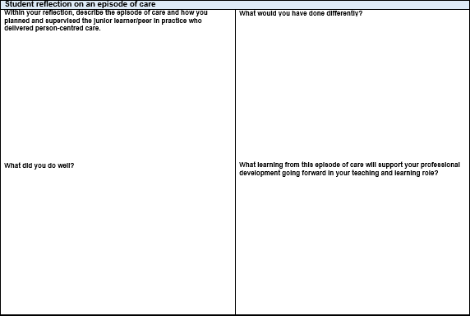  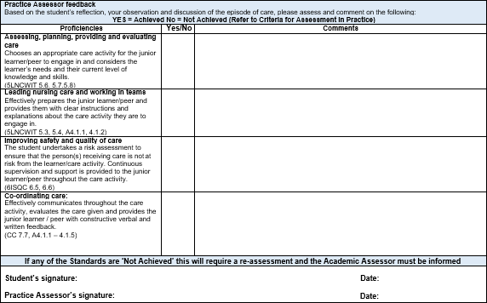

Medicines Management
The returners is required to undertake a Medicines Management assessment. This assessment must be completed by a Practice Assessor.  As there is only one opportunity for assessment the planning of the medicines management should be taken into consideration to maximise the learning for the returner. The returner should be allowed a number of practice opportunities to administer medicines under supervision prior to this assessment.  The returner should be consolidating their knowledge, skills and competence in relation to the safe administration of medicines within the required regulatory frameworks relating to Future Nurse (NMC 2018), The Code, (NMC 2015) and A Competency Framework for all Prescribers (The Royal Pharmaceutical Society 2016). | 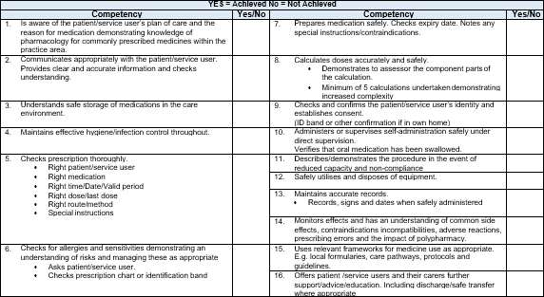

Action Plan
An Action Plan should be completed if there is cause for concern in relation to the returner’s performance. For example, failure to achieve components of assessment such as Professional Values.  If a returner requires an Action Plan, the Practice Assessor should liaise with the Academic Assessor and is responsible for reviewing progress and ensuring support and learning is available. Depending on the AEI and the practice placement’s policy, the Practice Assessor may have to inform the nominated person on placement.  FAQs  Q: What timescale should be used for the returner to achieve the Action Plan?  A: This will depend on the area of concern and the frequency of learning opportunities available within the length of the placement. The returner has to be able to attend and engage in learning in order to achieve the action plan.  Q: How much support and learning should be provided?  A: This will depend on the complexity of the area of concern. The returner has to be able to demonstrate competence and/ or professionalism.  Q: What happens if the returner does not achieve the objectives within the Action Plan by the stated review date?  A: The Practice Assessor will need to document their decision regarding whether the returner has failed the placement and communicate the outcome with the Academic Assessor. The returner will then have the opportunity to complete retrieval /refer placement. Failure to pass this placement will result in removal from or an opportunity to re-register on the programme. | 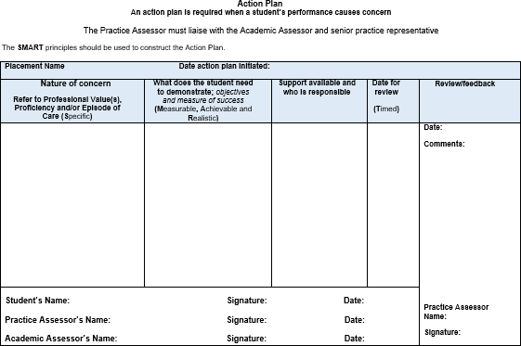

Record of Practice Hours
Returners are required to provide evidence of having completed the required number of practice hours for NMC Registration.  Members of staff on placement must verify the returner’s hours at the end of each shift/week on this form. Staff verifying practice hours must complete the relevant signatory page towards the front of the PAD.  Returners will have specific information from their university regarding how this is reported and recorded.  FAQs  Q: Is the staff member responsible for verifying all the hours recorded?  A: No, the staff member is only calculating those hours documented on the practice hour’s page. | 