PGCE FE Mentor Connect Newsletter 2022/23
Number 1
What are we doing and how does it fit together?
Welcome to the PGCE FE Mentor Connect newsletter which aims to show how all parts of the course fit together, outline UW delivery and how it links to professional practice, course dates and links to resources.

- How the course fits together

The PGCE FE course components are intended to be well integrated and work together effectively. Here is a diagram that the trainees designed to show their understanding of how the course fits together. We hope this helps explain the programme – feedback welcome!

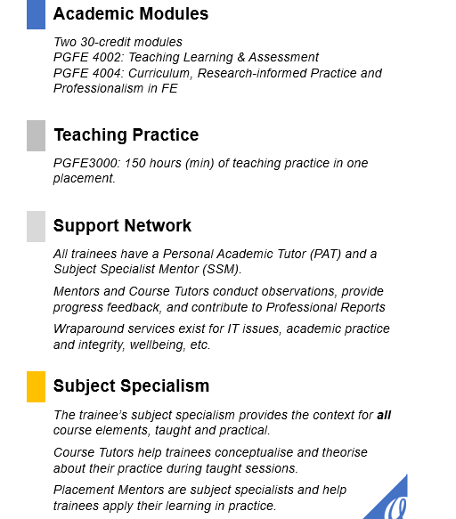
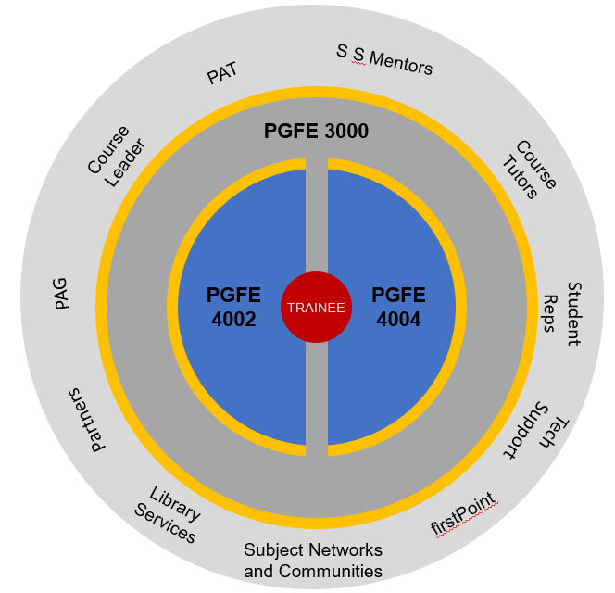

Fig 1 PGCE FE Course Modules and Components
- What’s been happening at UW and placement?

September – December
UW based content – so far
Concepts, knowledge, theory and modelling
The Sector – breadth of provision, learners, safeguarding, EDI (including legislation), FBV, policy past and present.
Learning and assessment theories -traditional (e.g., behaviourism) and contemporary (cognitive load theory); assessment and assessment for learning, monitoring progress, inclusive practice and individual needs; planning learning; subject specialism days curriculum; promoting positive behaviour (e.g., routines); wellbeing for all; professionalism including Curriculum and Practice Themes Booklet/PebblePad, mentoring (ETF Mentoring Framework)
Wider Professional Themes- embedding English and Maths, EDI, Education for Sustainable Development (ESD) and digital skills.

How to - UW and Placement activities
Practice/how to UW/placement: microteaching and teaching- plan, assess, evaluate teaching and learning; developing learning relationships, meeting individual needs; curriculum – models, sequencing; academic skills; reflective practice and critical skills (PebblePad), digital skills (ETF Digital Skills Framework); safeguarding; professional relationships; observations, discussion and target setting; formative assessment (Professional Report 2).

January - May
UW based content
Concepts, knowledge, theory and modelling
Curriculum – concepts and applications (e.g., PCK); learning from real world experience (methods and models)
Research – sector, subject, approaches – linking to professional dilemmas; research into learning relationships and young people.
Professionalism – CPD, EIF, career action planning, QTLS, peer visits, digital skills, safeguarding, FES case study visit.

How to - UW/placement
Microteaching and teaching - plan, assess, evaluate teaching and learning and further development of knowledge and skills; developing learning relationships, meeting individual needs; curriculum – models, sequencing; academic skills; reflective practice and critical skills (PebblePad), digital skills (ETF Digital Skills Framework); safeguarding; professional relationships; CPD; teacher as researcher; observations, discussion and target setting; coaching; summative assessment (Professional Report 3).

- Course assessments and assignments information

Trainees have made a good start on organising their observations. The first observation is a Joint Learning Observation (JLO) with a UW tutor. This can be used by mentors as a guide for future observation reports.
Trainees are expected to have at least 6 formal observations by mid/end of April.
Informal feedback, for example, observation feedback, team discussions, mentor catch ups, learner feedback and peer feedback is highly valued and trainees are encouraged to capture this as notes in PebblePad. NB: the PGCE FE Professional Practice Timeline and Checklist maps the dates and activities.

Placement dates and events
Placement dates 12th October – 25th May (there may be individual arrangements)

Mentor assessment dates
Professional Report 2 should be submitted by 17th February 2023
Professional Report 3 should be submitted by 26th May 2023

Mentor Connect Training and drop-in events
Mentor Training Part 2
Wednesday 1st March 4-5 pm on Teams

Mentor Drop-ins – 2-minute question? Checking in? Unsure about the observations or Professional Report? PebblePad issues
Friday 10th February 3-4:00pm on Microsoft Teams
Friday 19th May 3-4:00pm on Microsoft Teams

Mentor Connect Assessment updates
Trainee assignment submission dates
Assignment A Sequence of Lessons and Critical Commentary
Submission date 24th February 2023

Assignment B Literature review and professional development
Week beginning 15th May 2023
Presentation/ professional discussion with Mentor – trainee to share their research with you.

Summative assessment week beginning 5th June 2023 – join us to discuss your trainee’s achievements and next steps via Teams (individual invitations will be sent)

4. What resources are available?

Partnership pages – link here  Templates, examples, mentoring resources,  (updates live after half term).  New resources!  PGCE FE Course Map including Practice Themes  PGFE3000 Professional Practice Timeline and Checklist  PGCE FE Review of Progress against Curriculum and Practice Themes  Thank you very much for supporting our trainees. We look forward to seeing you at training and please get in touch if you have any questions. | Contacts  Jane Sisk j.sisk@worc.ac.uk  Course Leader  Mike Tyler m.tyler@worc.ac.uk  Course Tutor  Laura Rowland l.rowland@worc.ac.uk  Course Administrator

