Monday
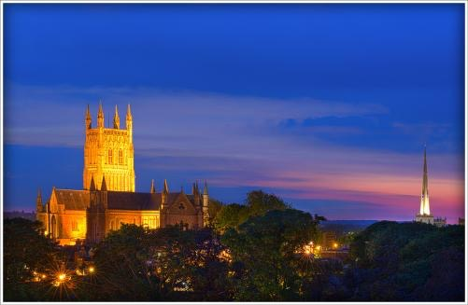
The day started with a couple of bird walks with all receiving a free apple. The walks and the bins (binoculars) did spark a bit of interest as students and staff wondered what they were up to, the twitchers saw a total of 19 different species of birds on campus that morning.
The nature fair took place in The SU with Green Peace, Friends of the Earth, Re-gift and Student Switch Off. Loads of students attended throughout the day especially popular were the free Chilli Plants and Ox Eye Daisies, in total 80 chilli plants were given way and it was so popular especially with staff that we had to set the stall up again later in the week. A photo competition was held throughout the week which were displayed in the SU. Students and staff held a community litter pick and the university milk float was ‘pimped’ with scrap store items to show the extent to which materials can be reused. The float was a star attraction throughout the week.
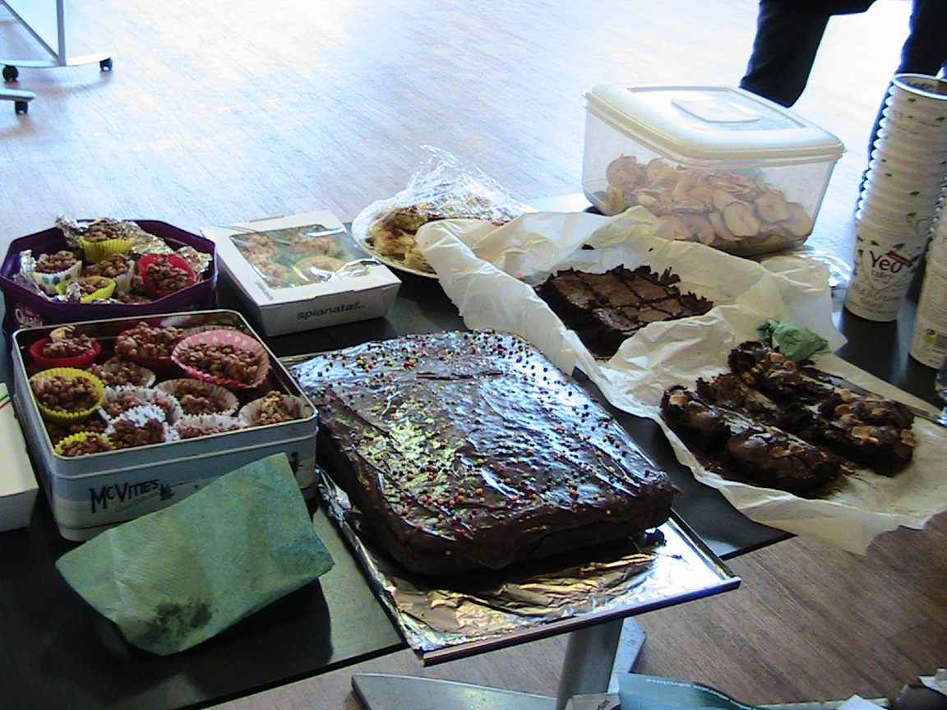
Tuesday
The Sustainability food fair was a flying success; we had cooking demonstrations, cake sales, food bank collections and a movie night!

Our aim with this event was to challenge our, and people’s, perceptions about food sustainability and thereby promote alternate ideas about the subject.

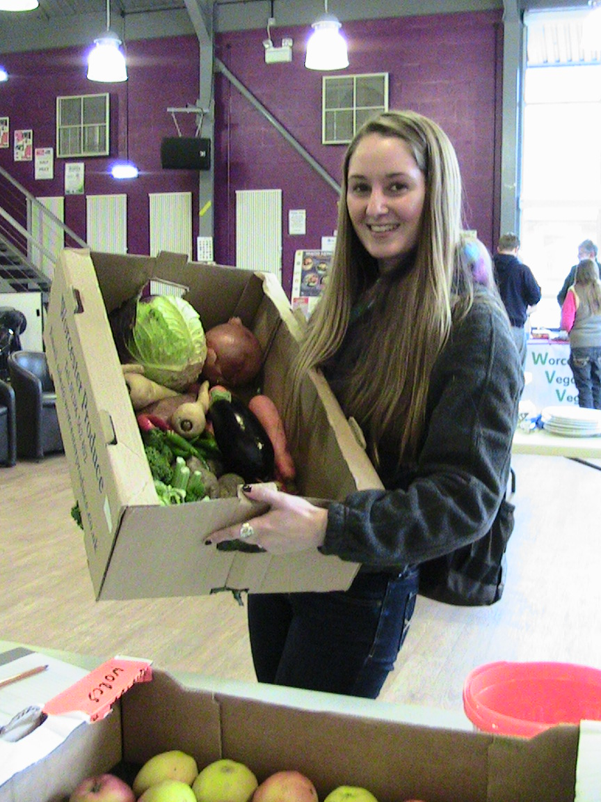
The Food Fair that took place in the university SU had a number of various stalls including: Worcester Vegans and Veggies, Zaytoun – Fair Trade, a cook off stand (featuring Local Food Lunches and Love Food Hate Waste) and finally a cake stall with dehydrated apples grown by students on the university allotments. These were a surprising hit, many students commenting just how intense the flavour becomes once dehydrated. All proceed for sales, over £64, went to the student campaigning charity People and Planet.

The cooking demonstrations created large crowds in the SU and queues to sample the food once cooked, the banana pancakes were so simple and a great way to use up an over ripe fruit. The Spicy cabbage had punters queuing up for seconds. Delicious.
Aramark, the university caterers helped us source a hamper with mixed vegetables and fruit, which was later given away to one lucky raffle winner with donations again going to People and Planet.

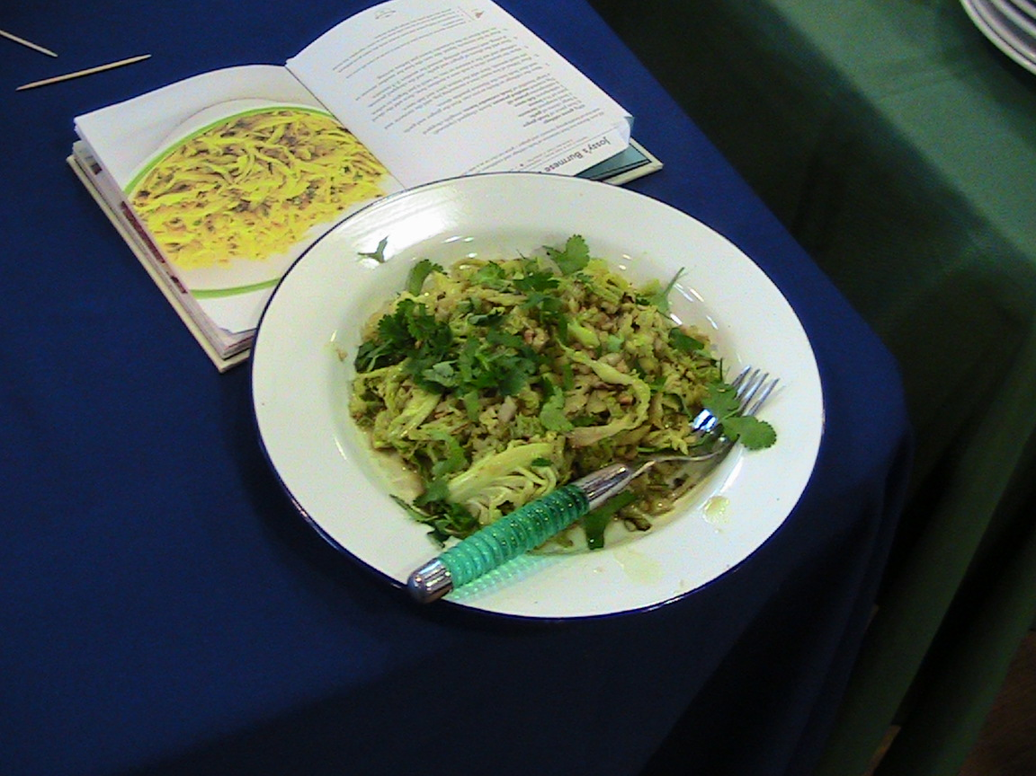
Part time carnivore stall had over 30 people pledge to not eat meat at least once a week, and finally we held a movie night screening Guardians of the Galaxy. We asked for an entrance fee of an item of food to donate towards the food bank collection. During the screening we also participated in a food bank collection bringing the day to a close, this amounted to 30.45KG in food for donation.

Wednesday
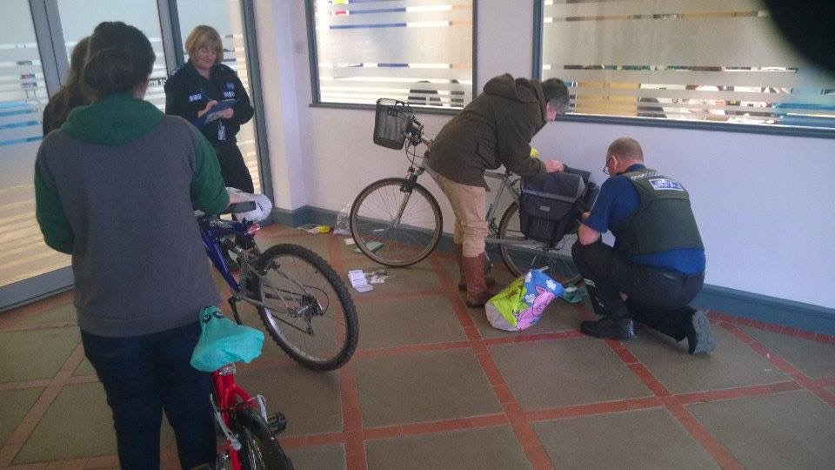
Wednesday was travel day for Go Green Week. The aim of this event was to raise awareness for sustainable transport and how people can get involved with it. We had 5 activities taking place during this day. This included a bike loan scheme, bike marking, a chance to ride an electrical trike and an external first bus company coming in to offer a great deal.
First bus offered a 3 for 2 deal in which you could get 30 bus journeys for the price of £10. This was the most sort after thing of the day as they managed to sell 198 tickets. We also had 32 students and staff sign up to use an alternative way of transport for one day during the week.
The dedicated Car-share was also a huge success as 7 people signed up for it on that day and more were enquiring about it being a long-term plan. Linking in with this we also had a bike loan scheme during the day in which we managed to sell 4 bikes which was another positive off the day.
We also managed to make an impact on a more local scale with a polar bear play. We sent a polar bear around Worcester with a camera on the buses to promote sustainability in terms of travel. This act was picked up by the local press which meant we managed to get even more publicity about sustainable travel.

Overall our day was a massive success as we managed to meet all the aims we set. So many students and staff participated in the activities which allowed us to raise awareness to a wider audience than we had anticipated.

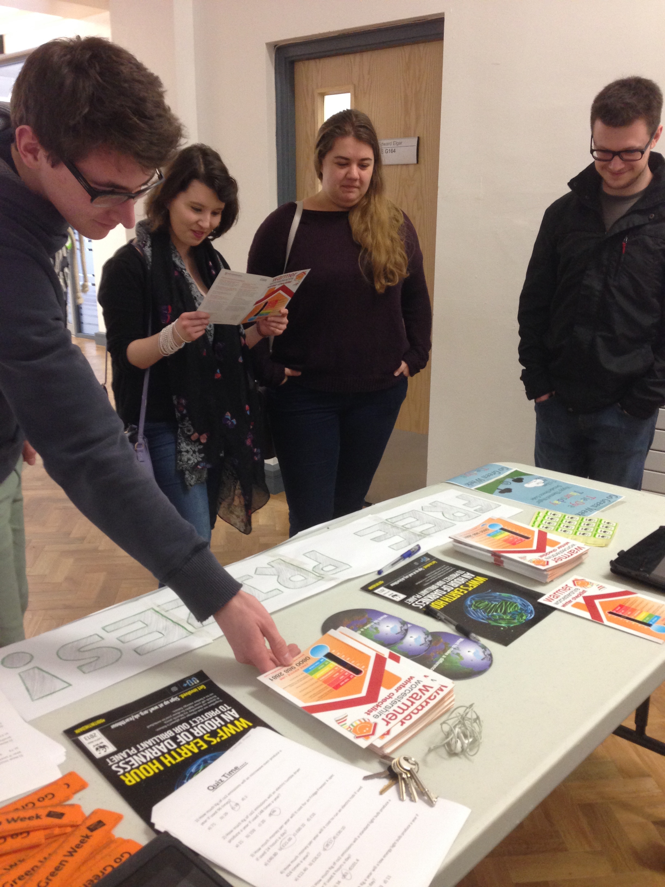
Thursday
Our day on energy was mainly to make people aware on the ways they could save energy in their households and on other energy related leaflets, for example WWF’s Earth hour and tips on how you can make a difference. We know that to get important messages across it’s important to have some fun. The more light hearted party with leaflets scattered about for people to take at their own pleasure.
The Pear tree was set up with tie dyed sheets, pillows and t-shirts, with the odd banner or 6. Just over 60 people partied, drank and perused the information, and had chat’s about what efforts they make to save energy at home. It was fun people enjoyed the quizzes. These are one of the many reasons we deserve to be Britain's 2nd greenest University.

Friday
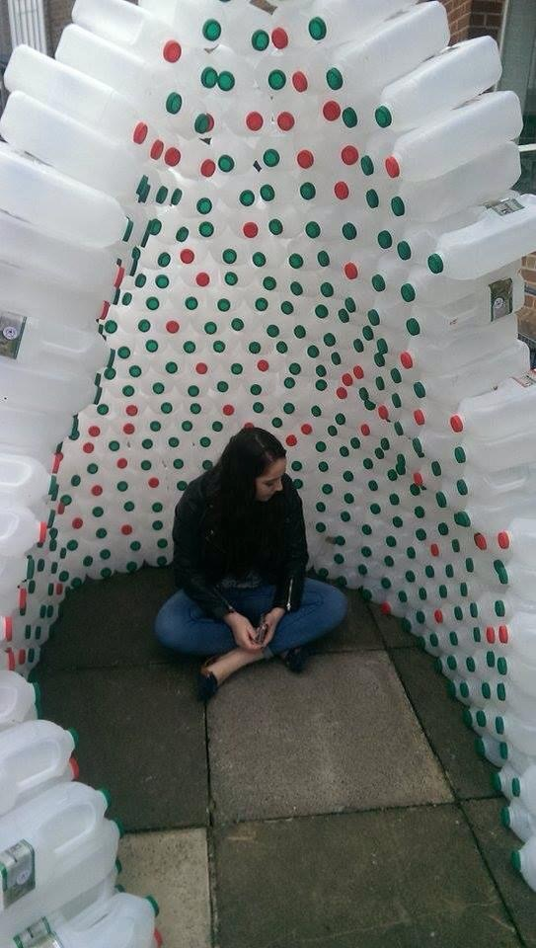
We hoped to inspire students attending the University and the public about their own carbon footprint. In particular we aimed to show the importance of reusing personal items or finding new uses for them rather than throwing them away, and recycling so that materials can be used again in the future.
Over 4 weeks, more than 720 milk bottles were collected by friendly staff across the university- including staff from the Aramark café- to enable us to carry out our igloo project- in which we hoped to raise awareness to the benefits of reusing and recycling.
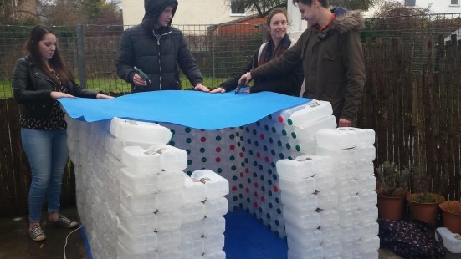
Structural issues caused a catastrophic collapse, many hours of labour lost, but not daunted our mission was to rebuild a more ridged structure for the reusing-promoting igloo. The build was a fantastic turn out the second time round at the UniTots Nursery on St Johns campus, although it was more cube-shaped the finished product looked absolutely fantastic and was a great area for the children to use to play, read or just chill- literally- in! Everybody watched in anticipation as the final homey touches were added such as the archway for the children to climb into and the [not so sturdy] roof.
The nursery run their own Go Green Week and also helped in our activities. They made their own polar bear headbands to join in with Pearl the Polar Bear- the Student Unions mascot. All of the children involved were under the age of eight, and according to author and psychologist Maureen Healy children are at their most impressionable age at this time, the nursery staff do work hard to help the children understand and learn about sustainability.
Finally the week ended with The Malvern Hills Repairs Café. Experienced and dedicated volunteers repair broken items whilst educating students so that they can fix things for themselves in the future. The repairs café saw 15 items fixed in the space of two hours. The success of the event we hope means this will become a regular feature on campus which has made benefits for students financially and sustainably as well.
In total, we could have reached over 415,000 people over the week. This number is only an estimate and assumes everyone has seen our press releases and adverts. This number includes the 10,095 students at the university, 23,133 paper readers of Worcester news, and 332,250 unique online readers, plus 48,986 printed copies of the Worcester Observer. It does not include parents, friends, family, and colleagues who may have heard about our project through word of mouth. Certainly we all learned and enjoyed the week and found out we could make a difference.
The year one sustainability elective students 2015

