How to Find Us
For information on how to find the 3 main sites - St John's Campus, City Campus and Severn Campus, please see the link below.
http://www.worcester.ac.uk/discover/find-us.html

Your Online Timetable
When you first log on you will see the following timetable window.
This will display all of your timetabled activities. Your timetable is subject to change, so please ensure that you check your timetable on a regular basis.
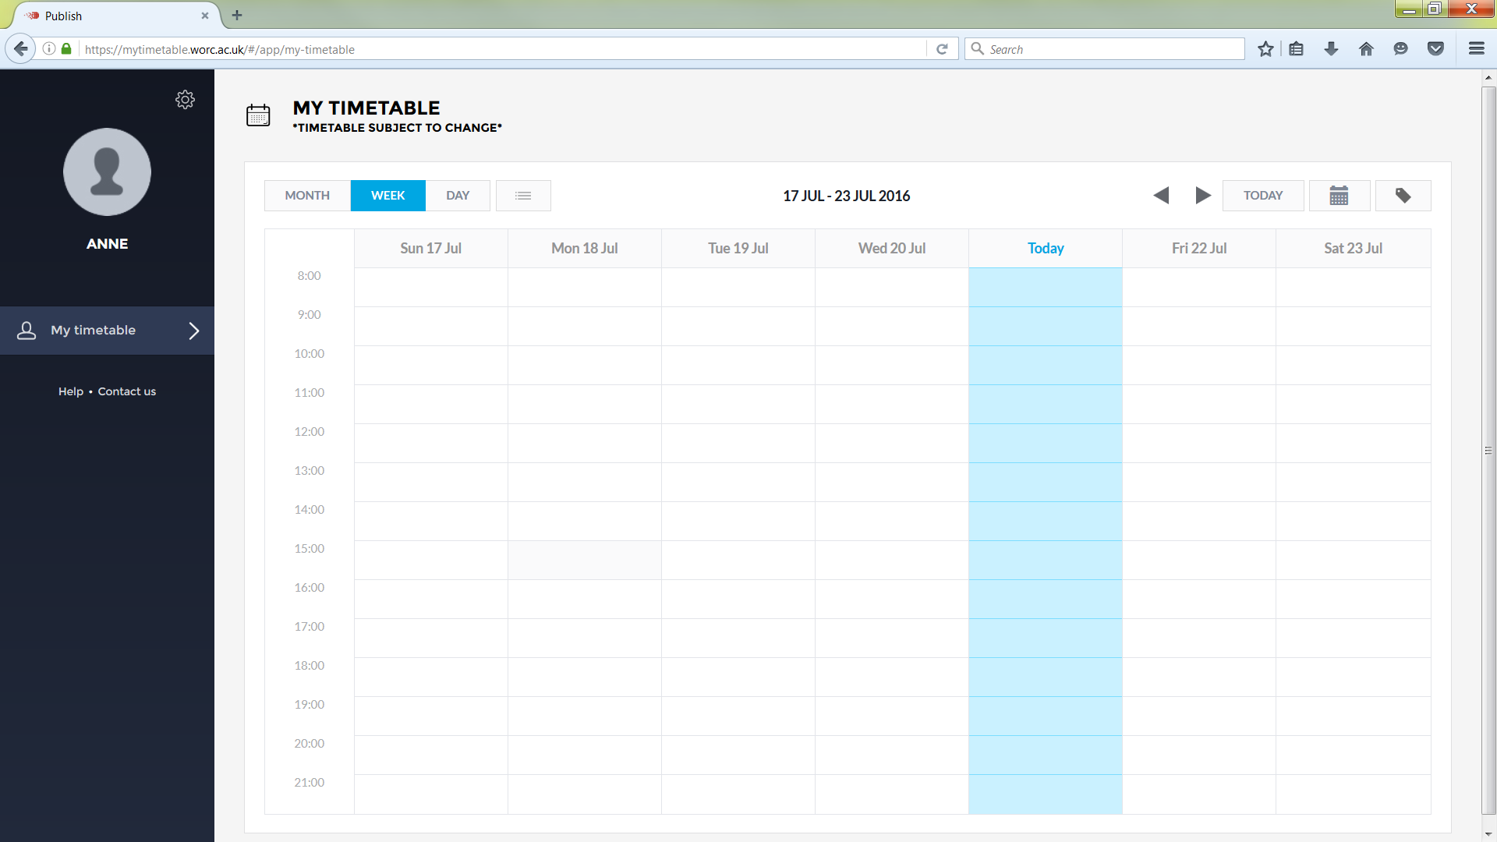
You have options to see your timetable by Month, Week or Day by clicking on the links below:-
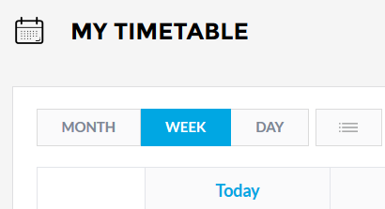
Additionally, located on the top right of the timetable you will see these links:
The forward and backward arrows allow you to move between months.
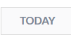 This icon shows you your timetable for the current day.
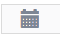 This icon provides you with slightly different calendar options, which allows you to select specific dates across months.
This icon shows the different colours for different types of activities shown on your timetable (i.e. Lecture, Seminar or Practical).
By clicking this icon (which is above the University logo) you will open the Edit Profile window, shown below:
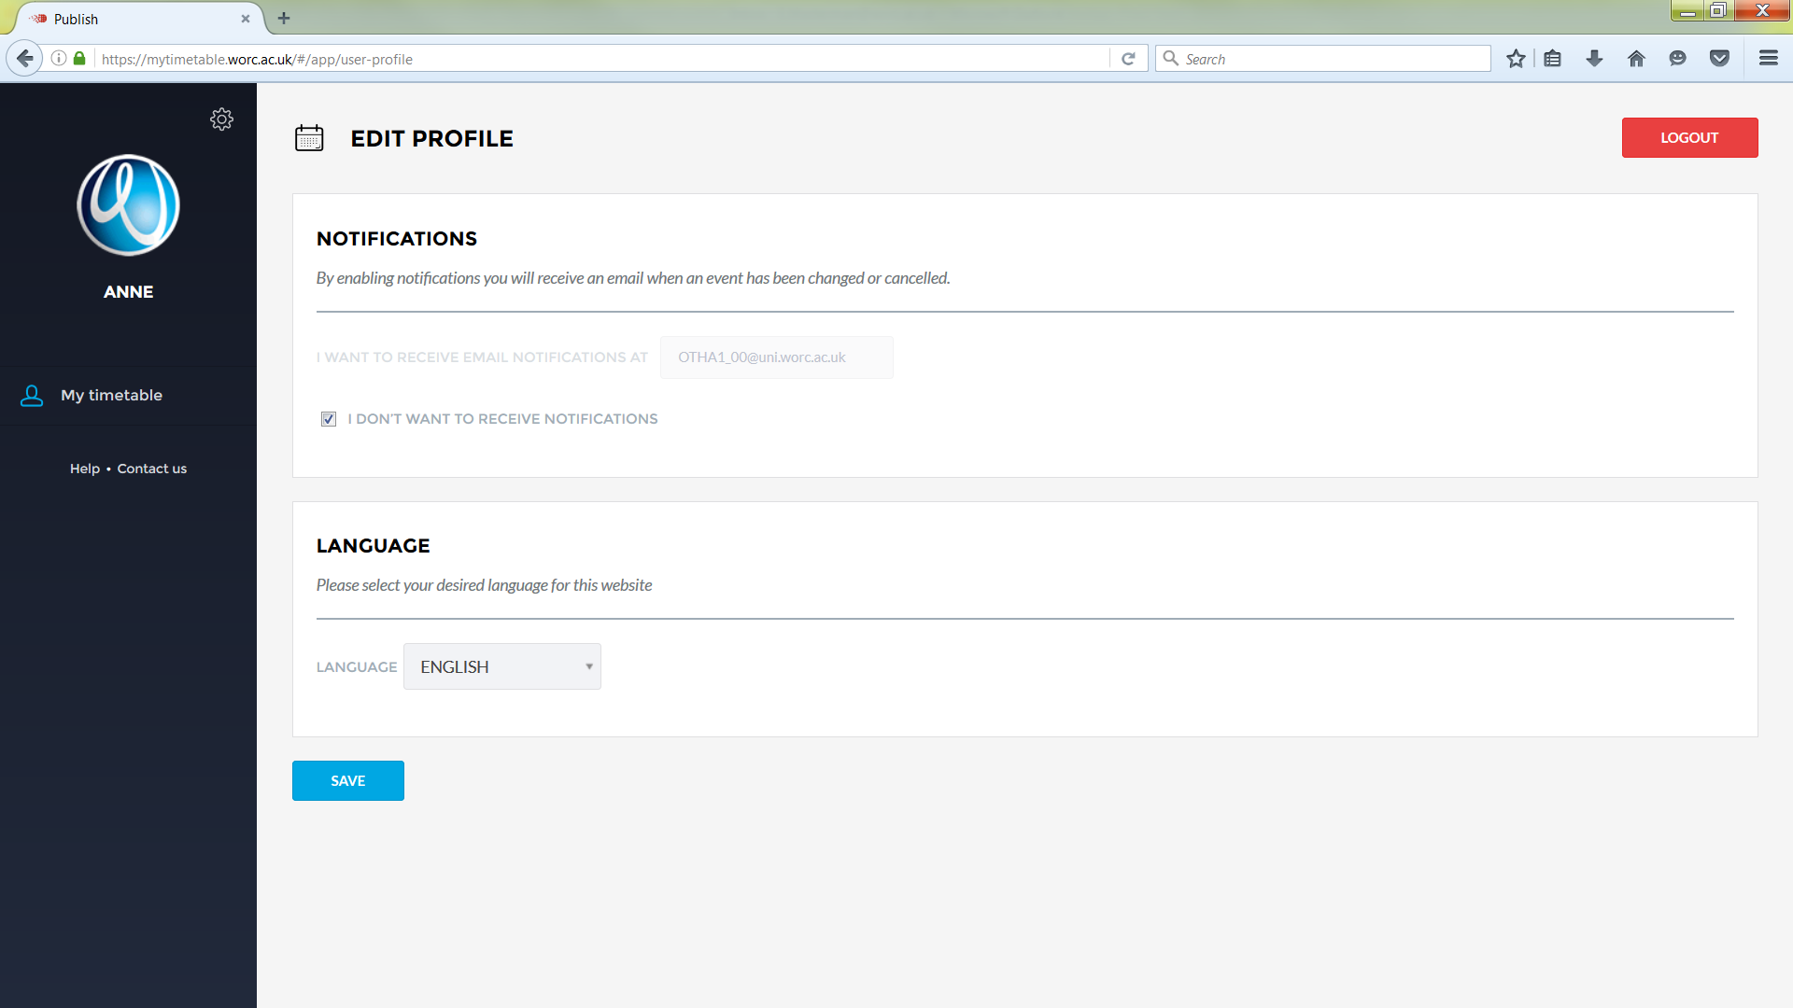
The logout button is located on the top right of the screen.

Email Notifications
You can receive email notifications letting you know of in week timetable changes.
The default setting is to NOT receive email notifications letting you know of short term (in-week) timetable changes.
It is strongly recommended that you opt in. To do this you untick the tick box, shown below:-
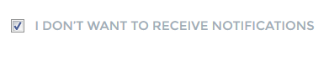
Your university email address is already pre-populated into the box below.
Once completed it should look this like.
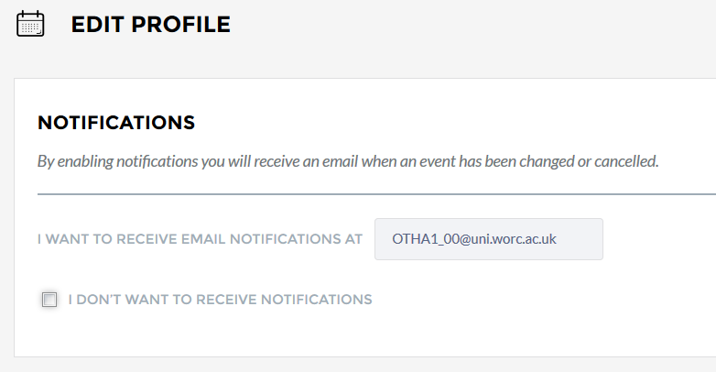
Make sure you click the Save button to retain your changes.

Your timetabled activities
Your timetabled activities are displayed within the My Timetable window. Different colours identify the different types of activities shown on your timetable (i.e. Lecture, Seminar or Practical).
Below is a screenshot showing Lecture activities.
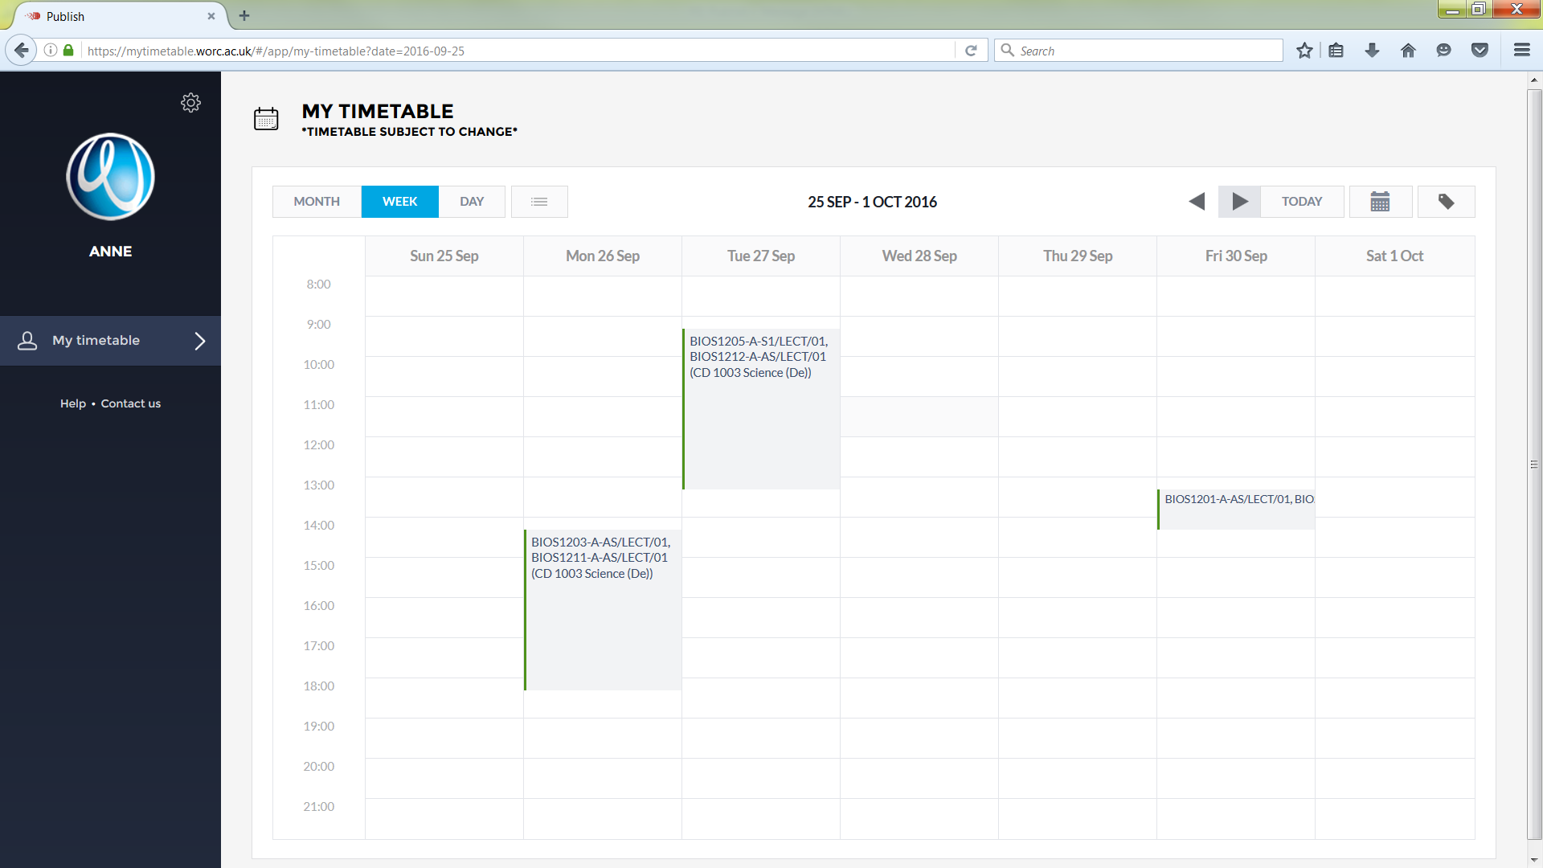

Changes to your timetable
Your timetable is subject to change. So please ensure that you check your timetable on a regular basis.
In week timetable changes

If any changes are made to your timetable/rooms within the same week it will be delivered, you will receive an email notification to your student email address (please note as this is an opt in service you will only receive these emails if you have opted into them).

Timetable changes made longer than one week in advance

These changes will be reflected directly into your timetable and no email notification will be sent. So it is really important that you check your online timetable regularly!

Moving seminar or practical activities
If you want to keep your module choices but need to change your activity on a particular module (e.g. seminar or practical), then you must discuss this request with your module tutor who will notify timetabling of any changes that are agreed.
Module Change Requests
The process on how you can request to change modules and how this will be reflected in your timetable can be found by clicking on the Contact Us icon which is shown below.
